NAME: - V.UMESH KUMAR RAJU

REG NO. :-20MIS0187

DATE: - 15/10/2020

ACTIVITY:-1

Write a python program to calculate the total number of even numbers and total number of odd numbers exist between any two given integers say number 1 and number 2.

Print the results properly.

**ALGORITHM:**

1. Start
2. Read a as the starting range and the b as the ending range.
3. Assign i=a, count_odd=0 and count_even=0 where count_odd and count_even will used to count the odd and 3even numbers.
4. Till i<=b

* Check if the reminder is zero when i is divided by 2(i%2==0) then update count_even = count_even+1
* Else update count_odd=count_odd+1

Then update i = i+1

1. Print count_odd as the number of odd numbers in the range.
2. Print count_even as the number of even numbers in the given range.
3. Stop

**Program:**

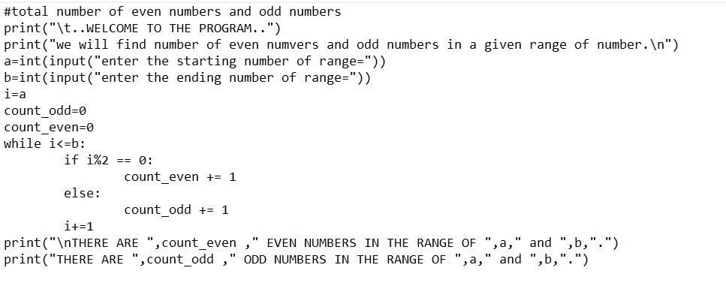

**Output:**

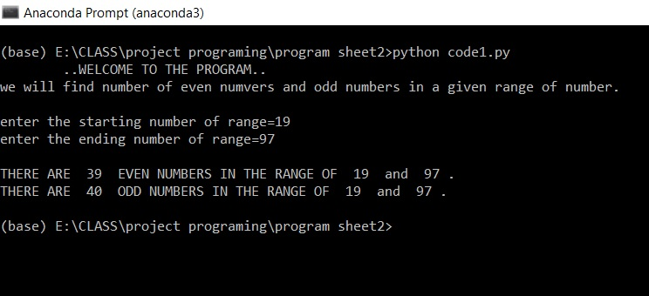

ACTIVITY:-2

Write a python program to find the sum of all digits of a given integer. Print the result.

**ALGORITHM:**

1. Start
2. Read num as the number.
3. Assign copy=num, sum=0, copy1 = string of num and lastd as the reminder when num is divided by 10 (num%10).
4. While copy is not equal to 0

Evaluate a=copy%10(reminder when copy is divided by 10)

Update copy=integer value of copy/10

Update sum = sum +a

1. Print sum as the sum of all the digits.

**Program:**

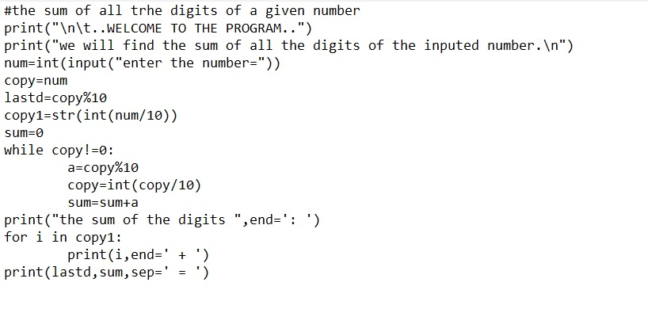

**Output:**

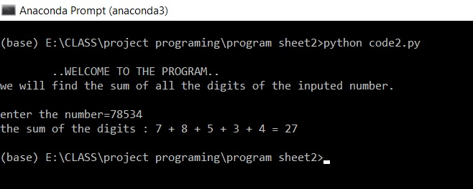

ACTIVITY:-3

Write a python program to add any 5 random numbers using random () between the giver range (number1 to number2). Print the sum.

**ALGORITHM:**

1. Start
2. Read a and b as the starting and ending range for finding the random numbers between.
3. Assign i=1 and sum=0
4. Import random module
5. While i <= 5

Evaluate number=random.randrange(a,b) where computer produce a random number in the range of a and b.

Update sum=sum+number

If i not equal to 5 then print number and “+”

Else print number and “=”.

1. Print the sum as the sum of random numbers.
2. Stop

**Program:**

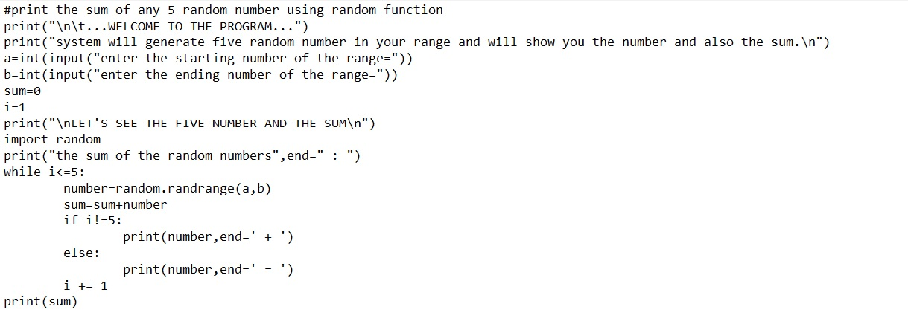

**Output:**

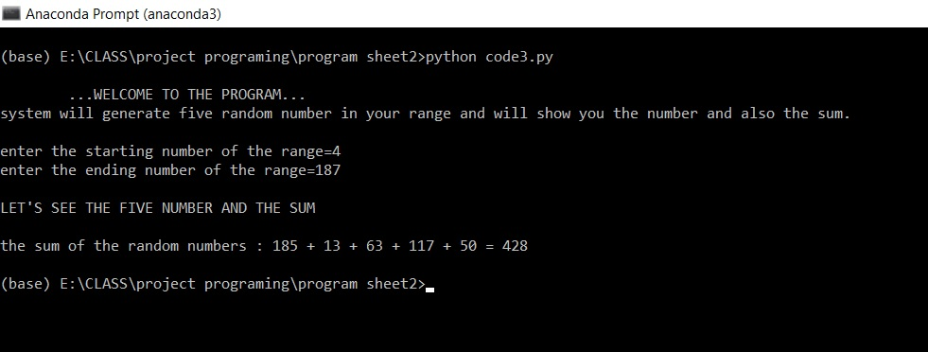

ACTIVITY:-4

Write a python code to print the data type of a variable. Test your program with integer, float, string data types with examples.

**ALGORITHM:**

1. Start
2. Assign x=5

y=5.8

z="HELLO"

1. Read a
2. Evaluate the data type by

xtype=type(x)

ytype=type(y)

ztype=type(z)

atype=type(a)

1. Print x ,y,z value
2. Print xtype as the data type of x and ytype as the data type of y and ztype as the data type of z and atype as the data type of the entered value.
3. Stop

**Program:**

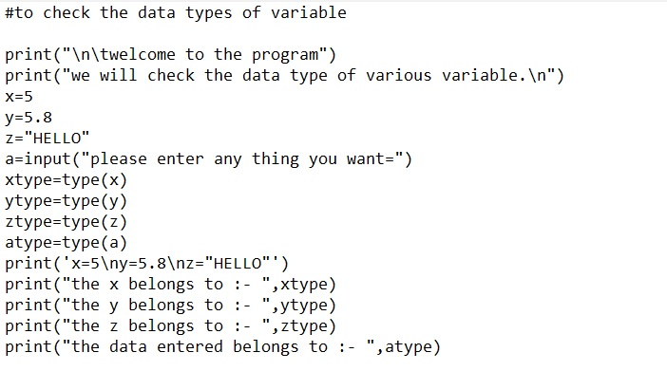

**Output:**

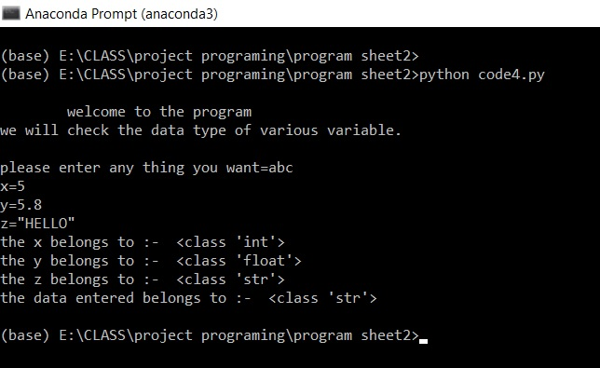

ACTIVITY:-5

Write a python program to print the following patters.



**ALGORITHM:**

1. Start
2. Read n as the number of rows.
3. Assign i=n
4. While i>=1

Assign j=i

While j>=1 print j and space at the end insted of new line and update j=j-1

Update i=i-1

1. Stop

**Program:**

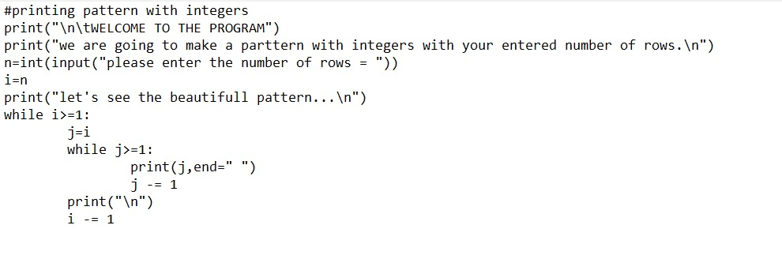

**Output:**

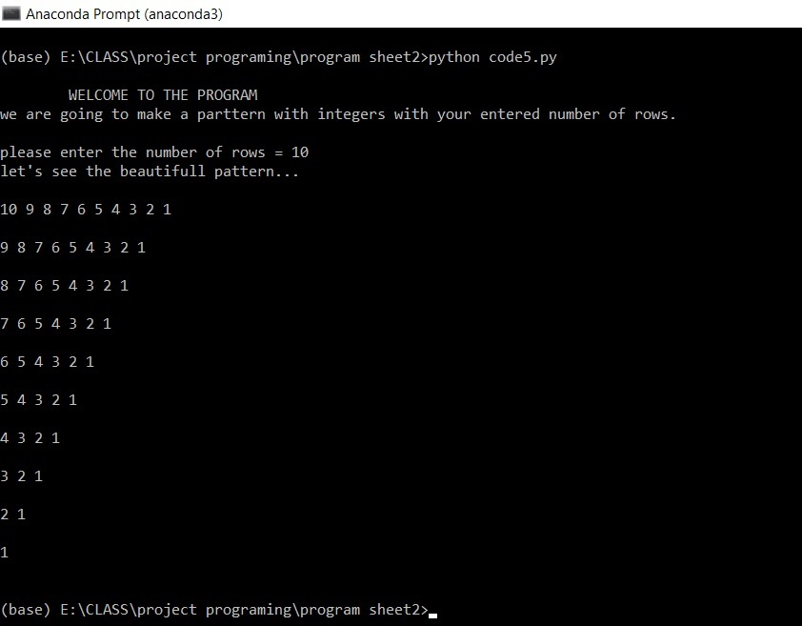

ACTIVITY:-6

Write an interactive python program to read the +2 marks (say for 5 subjects) from a student and print the total marks, average marks and result (PASS/FAIL).

Note: If a student scores less than 50 marks for any one subject, then that student fails in +2.

**ALGORITHM:**

1. Start
2. Read sub_eng, sub_maths, sub_phy, sub_chem, sub_comp as the marks of English ,math, physics, chemistry, computer. And assert all the marks between 0 and 100.
3. Evaluate

total_marks= sub_eng+sub_math+sub_phy+sub_chem+sub_comp as the total marks

1. Evaluate avg_marks=total_marks/5 as the average marks.
2. if sub_eng>=50 and sub_math>=50 and sub_phy>=50 and sub_chem>=50 and sub_comp>=50 print you have passed your examination.

Else YOU HAVE FAILED THE EXAMINATION.

1. Print total_marks as total marks and avg_marks as average marks.
2. Stop

**Program:**

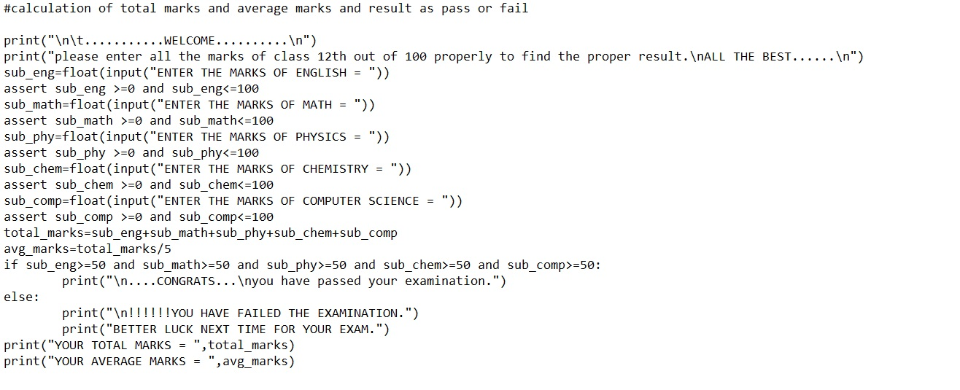

**Output:**

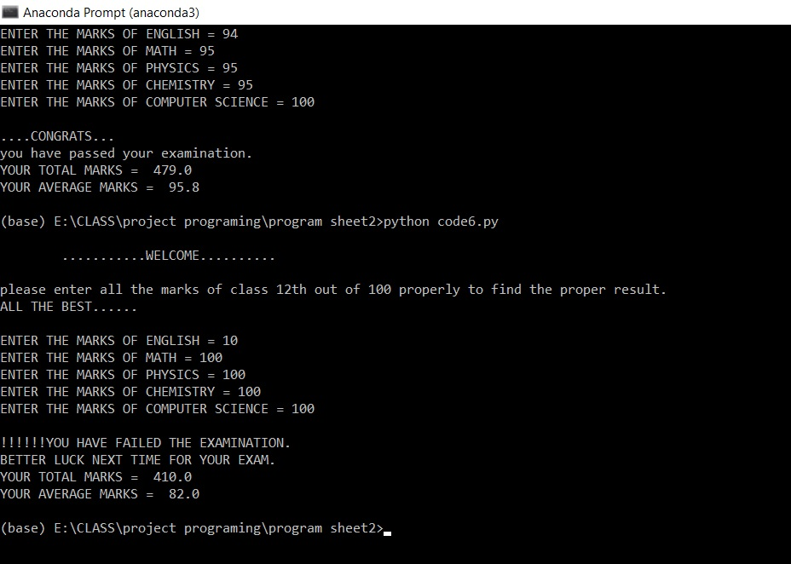

ACTIVITY:-7

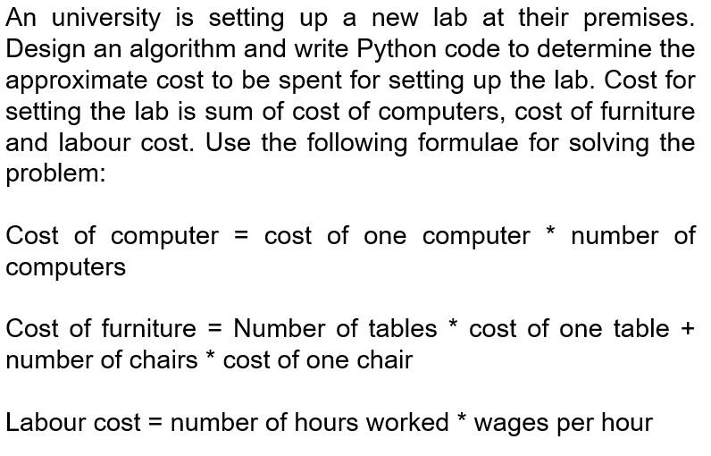

**ALGORITHM:**

1. Start
2. Read comp, table, chair, worker as the cost of each computer, table, chair and wages per hour of worker respectively.
3. Read qty_comp, qty_table, qty_chair, hr_worker as the number of computers, number of tables, number of chairs and hours workers worked.
4. Evaluate

cost_comp=comp*qty_comp as the total cost of computers.

cost_furniture=(table*qty_table)+(chair*qty_chair) as the total cost of furnitures.

cost_worker=worker*hr_worker as the total cost of labour.

budget=cost_comp+cost_furniture+cost_worker as the total budget for lab.

1. Print

cost_comp as the total cost of computers, cost_furnitureas the total cost of furnitures, cost_worker as the total cost of labour, budget=cost_comp+cost_furniture+cost_worker as the total budget for lab.

**Program:**

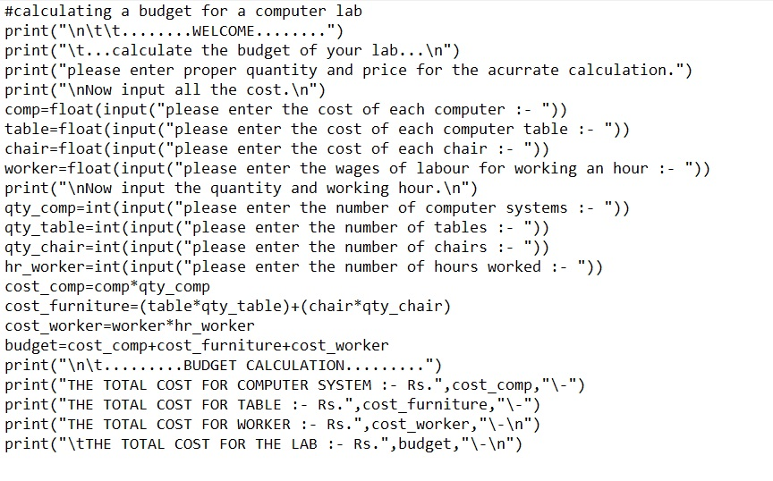

**Output:**

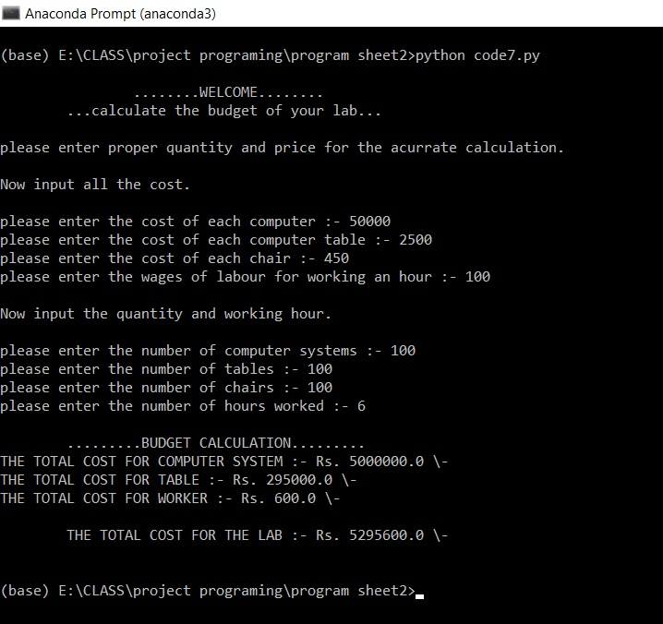

ACTIVITY:-8

Write a python program to check whether a given number is palindrome number or not.

**ALGORITHM:**

1. Start
2. Read num as the number which is to be checked
3. Assign copy1=num and new_num=0
4. While copy1 not equals to zero

Evaluate rem = copy1%10

Update new_num=new_num*10 + rem

Update copy1=integer value of copy1/10(int(copy1/10))

1. Print new_num as the reversed number of original entered number.
2. Check if num == new_num then print the number is palindrome

Else print that the number is not a palindrome.

1. Stop

**Program:**

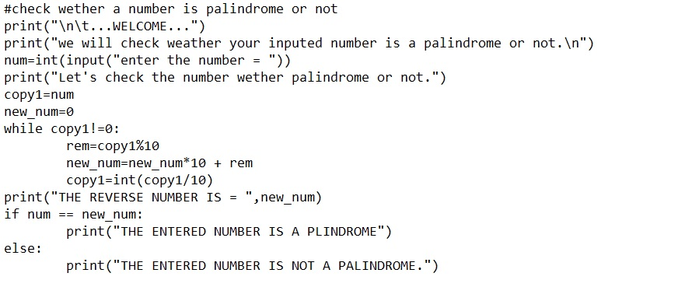

**Output:**

